TEAM 3

Alyssa Ballestro, Nicholas Bercier, Richard Homan, David Melilli, Colton Shambaugh, Phillip Waldecker

Elevator Final Project Report

EEGR3213: Digital Electronics

Date Due: April 31, 2023

Date submitted: April 28, 2023

Teacher: Dr. Joon Wan Kim

**Table of Contents**

**Introduction...................................................................................................................................3**

Overview.............................................................................................................................3

Problem Statement..............................................................................................................3

Specifications......................................................................................................................4

**Project Design................................................................................................................................4**

Approach Used....................................................................................................................4

Block Diagram....................................................................................................................5

**Implementation.............................................................................................................................**6 Methodology.......................................................................................................................6

Connection Diagram...........................................................................................................6

Results.................................................................................................................................7

**Discussion......................................................................................................................................7**

Difficulties..........................................................................................................................7 Solutions.............................................................................................................................8

**Conclusion.....................................................................................................................................8**

Performance Description....................................................................................................8

Unsolved Problems.............................................................................................................8 Future Work........................................................................................................................8

**Introduction**

Overview:

Our team was tasked with making a fully operational four floor elevator by the end of the semester. The elevator needed to have buttons that light up and stay as such until the elevator reached the corresponding floor. We were required to use a CPLD chip given to us and use only VHDL for the coding side of the project. In the end, the elevator worked, but was very buggy. The appearance was decent, and the motor worked most of the time. The main issues were the elevator getting stuck on some of the floors and refusing to move and the wires being very finicky on how close they were to other wires and components.

Problem Statement:

The task of each team was to create a four-floor elevator controller with four control buttons labeled 1 through 4, each with an LED indicator. The elevator controller had to be able to move up and down, stop at each floor, and respond to the control buttons. The teams were given a set of rules and guidelines to follow to ensure functionality. Pressing a button will move the elevator to the requested floor and turn on the LED for that button. Multiple floor requests can be accepted, and the elevator will move directly to the requested floors using the shortest path. The elevator must be able to go to any floor from any floor and hold on that floor for a minimum of three seconds. The buttons must light up when pressed and be turned off once the elevator gets to that floor. A specific language, VHDL, must be used alongside the CPLD chip. VHDL is a hardware description language used to model digital circuits. The CPLD chip is a programmable logic device that can be programmed using VHDL to implement the desired functionality. The time given was approximately one month. We began our plan immediately. We divided the tasks among the team members and set deadlines for each one to ensure that we finish everything on time. Additionally, we regularly checked our progress to make sure we were on track to meet the deadline.

Specifications:

The elevator needed to be able to go to any floor, from any floor, and hold at that floor for a minimum of three seconds. Next, the buttons had to be separated from the elevator system. The buttons must light up when pressed, activate the elevator to move, and be turned off once the elevator gets to that floor while not affecting another floor. VHDL must be used alongside the CPLD chip to generate the code given to each component within this project. All of this was to be functional and able to be displayed on a concrete counter mounted to a wall in the hallway, which would then be continuously used by young adults.

**Project Design**

Approach Used:

First, the elevator needs to be able to go to any floor, from any floor, and hold at that floor for a minimum of three seconds. Next, we should not include the buttons in the elevator, but have them on a panel outside the elevator. The buttons must light up when pressed and be turned off once the elevator gets to that floor and not affect another floor. A specific language, VHDL, must be used alongside the CPLD chip. We started brainstorming immediately. A lot of us already had years under our belts for the assignments we were given. First a model was built, we delegated what we should use to make the elevator go up and down, how the buttons should be oriented, and materials for the project. We split up the team for each to work on their own specialties. We built the shell for the Elevator mechanism, developed the physical side of the elevator lifting mechanisms, began the circuitry and made the block diagram, and wrote code. As we each did our own specialties, we’d have meetings twice a week. While some would be unable to make it there was needed collaboration within the group at the given times. We set due dates for one another and went beyond what we thought was achievable. It was a miracle we got everything to work when it did. There were many downfalls with circuitry and coding. In the end the system was completed before the due date.

(Block Diagram)

**Implementation**

Methodology:

(Connection Diagram)

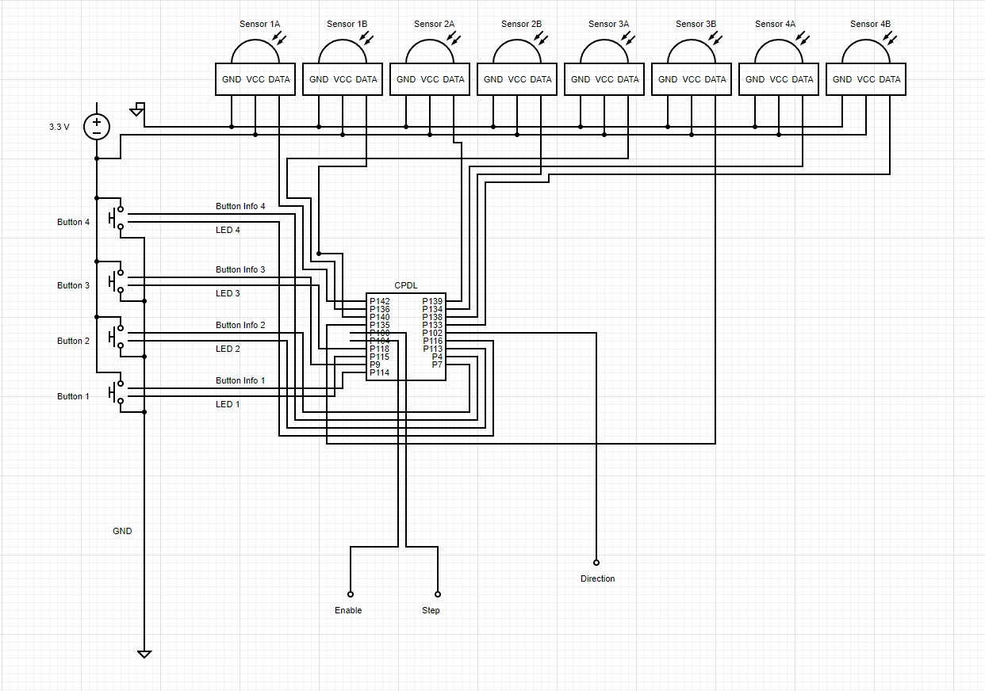 The connection diagram provides a detailed and informative visual representation of the intricate inner workings of our system, outlining the complex interactions between various components. At the heart of this system is the Complex Programmable Logic Device (CPLD), which has been programmed with the necessary code/VHDL to control the LED inside each button and register any operator input. Additionally, each button has been meticulously wired and connected to the CPLD, allowing for seamless communication between the system and the operator. Perhaps the most crucial component of the system was the "direction" output wire, which connected directly to the motor and dictated the direction in which it turned, clockwise or counterclockwise. The diagram had to consider the different button presses to synch with the motor, which was difficult considering how the wires were coupled together in a pile underneath and behind the two components.

Results:

Our team ended up making a fully functional four-floor elevator. By utilizing a script created by our team and many hours of construction, the first test with our stepper motor moving the elevator up and down to each floor worked on the first try. There was no shaking, missed floors, and no major issues seen. Issues arose as we began to secure different components inside of the elevator itself, which has now become a feature. In short, it works, but is buggy as can be.

**Discussion**

Difficulties:

From the start of the project, many issues arose. The first of which was the code not being uploaded to the CPLD. The Virtual Machine we used, and the ISE used to edit and upload code is notoriously difficult to get working and we honestly never did. The language was also very new to our team. Also, the super glue that held the IR sensors in place was prone to breaking if too much force was applied to the sensor from most directions (pushing in, shifting it side to side, etc.). Another major difficulty was power. This problem had two components: how much voltage was needed for all the parts in the system, and how do we step down the outlet voltage of 110 volts. On the more mechanical side, the sheet metal that was used for the physical structure was prone to warping. The linear rail, which was necessary for the elevator to have an accurate vertical motion, was often misaligned due to the structure shifting and curling under the heat. There were also many issues with wiring. The wires that were given along with the boards obtained did not stay together. The team soldered down some of the parts, but for other parts we had to use breadboards which caused a lot of interference and errors for our team. There were also many faulty connections due to loosened wires. The team took a lot of time to deal with these due to the unknown nature of which wires were faulty or even if the code was yet again the one to blame.

Solution:

With all the problems we had, they all had a solution. The CPLD may not have taken the code from one computer, but there was another computer that allowed us to upload the data from there. We had to use the backup code we were making, and it took a combined 30-40 hours to finish. The super glue was later replaced with JB Weld epoxy, which holds the IR sensors in place and does not get nudged off as they did before. For the voltage issue, we repurposed an IEP1 Ender 3 power supply box to bring the original voltage in the wall of 110 volts down to 15 volts, which could be distributed to the systems after a resistor as 12 volts to the stepper motor and with a voltage divider and our voltage regulator, could send 5 volts to our IR sensors and the CPLD. For the mechanical warping, hammering out the sheets after being welded sufficed for reforming the pseudo-flat surfaces.

**Conclusion**

Performance Description:

After the project was made, it worked very efficiently. If a button for a floor was pressed, the elevator moved to that floor and stayed there for almost 3 seconds. If there was another floor button pressed before or during the elevator’s stationary position at the floor it just moved to, the elevator would move to that floor and repeat the 3 second delay. The linear rail does not impede the motion of the elevator, nor does the pulley have any obvious issues. Yet there are some bugs that make it unable to function to the best of its ability. There is no longer any coupling, and we were able to work under the conditions given.

Unsolved Problems:

VHDL with the CPLD was very hard and barely worked. If it weren’t for someone from the previous year who had been running CPLD we wouldn’t have completed the project as we had. Three of our team members, along with an outside help, installed the CPLD onto the VM offered. We found that the CPLD did not work in Windows 8 or 10. They were able to work to an extent but shut down when another file was opened, the program was uploaded, and other nagging errors. We found it best to work in a VM that had a Linux ISO. The first file was created in the Windows 10 VM, which ended up with all the code that was developed to be corrupted when it was saved and unable to be uploaded to the CPLD fully. A big one is the carriage can get stuck on a floor, and never want to leave it until you move the motor a bit or move the carriage off that specific floor. Another bug is it goes fully one way and then reverses, or it simply cycles one way until it rewinds the paracord and starts to move again. All these problems were able to be fixed by bypassing something we originally used, so it wasn’t truly solved by the method we used.

Future Work:

If we were given more time to complete this project, or could add or modify it going forward, we would have made it strong enough to move a metal box up and down. Originally, our project had the elevator as a metal box, but it was too heavy for the stepper motor, so we cut off the back. Smoothing out the system to have better accuracy and making it less clunky would also be a project. Aesthetics would also have been great to add on, but our team sought functionality over beauty. We also wanted to add a system that allowed for elevator music as the elevator moves, but due to time constraints we went with the required first and were unable to add those components. Overall, the team did well to build the system to the specifications, but as we continue to grow, we will seek better improvement.